1. Go to MasterCard Connect and login with your employee number and RSA Secureid key:

<https://www.mastercardconnect.com/public/extranet/login/workspace.html>

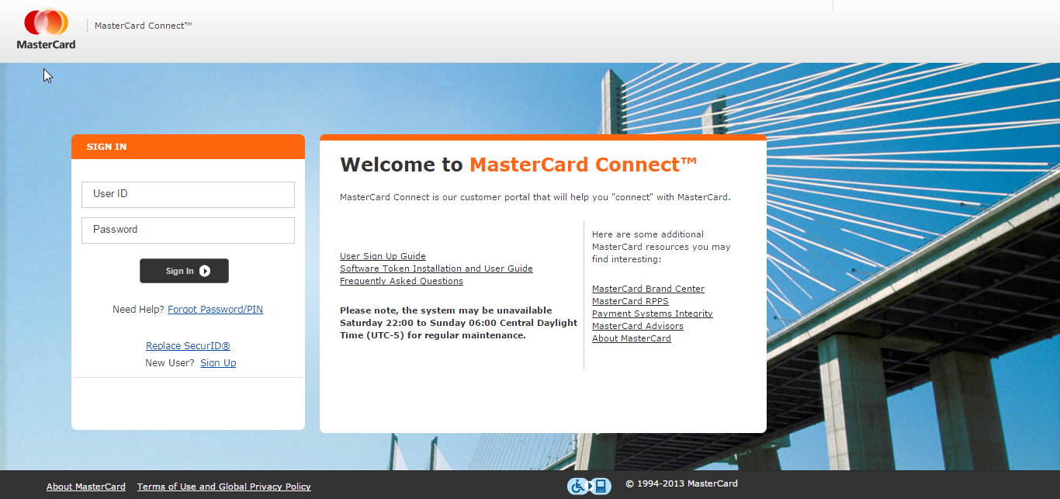

1. Click on “Applications” 🡪 “MasterCard Data Exchange”

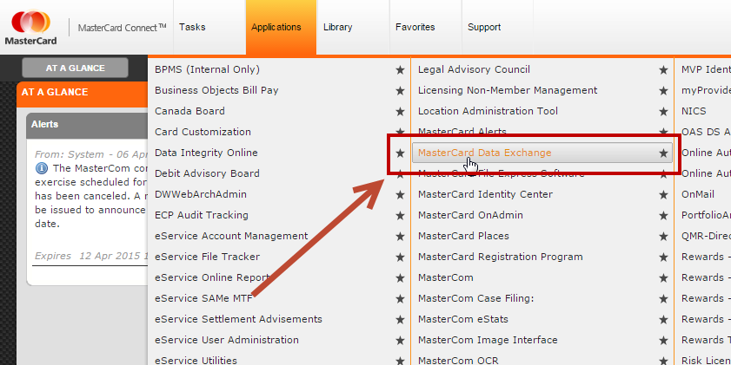

1. On the left click on “Endpoint E0071164”, this is the endpoint for our production unix server where the files will drop:

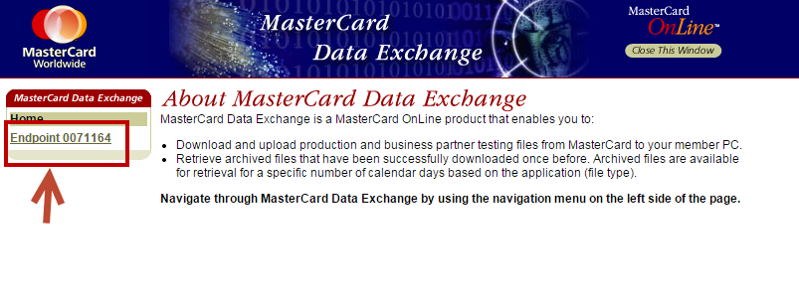

1. Click on “Upload Files” on the left:

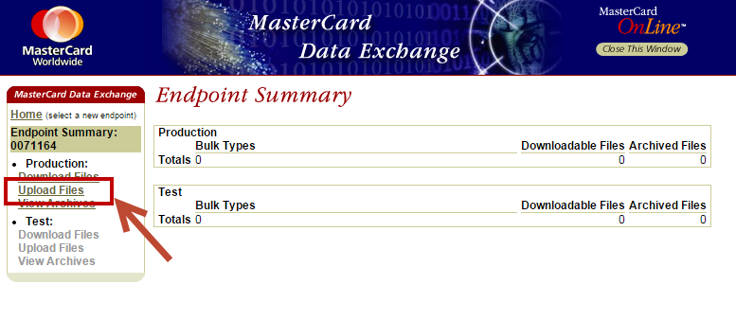

1. Select the bulk type you want to use to upload your file:

|  |  |
| --- | --- |
| ***Bulk ID*** | ***Description*** |
| RGY1 | Add/Replace Timed Release |
| RGY3 | Delete Timed Release |
| RGY5 | Add/Replace Immediate Release |
| RGY7 | Delete Immediate Release |

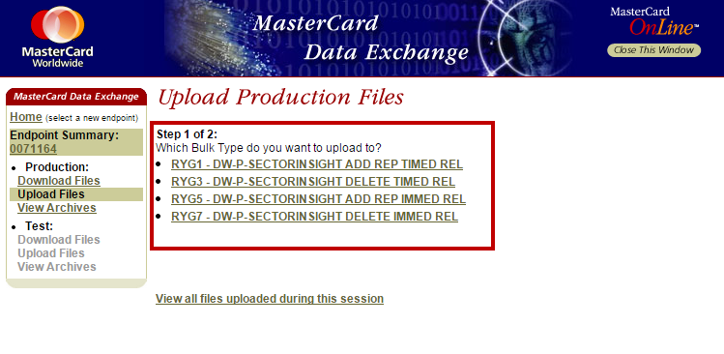

1. Click on “Choose File” and a dialogue box will pop up to allow you to select the desired file (PLEASE NOTE: after this step the file HAS NOT BEEN UPLOADED)

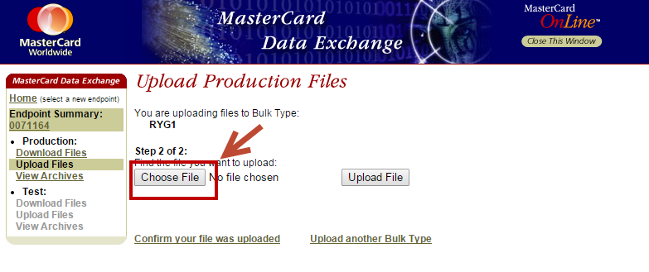

1. Click “Upload File” to push the file to the DataWarehouse:

